Based on <https://www.crcpress.com/downloads/K11527/MATLAB%20Resources.pdf>

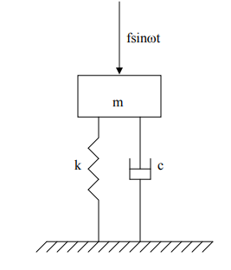

Turning this into state space gives

$$\dot{q}=Aq+Bu$$

$$y=Cq+Du$$

$$m\dot{q_{2}}+cq_{2}+kq_{1}=u$$

$$\dot{q_{2}}=-\frac{k}{m}q_{1}-\frac{c}{m}q_{2}+u$$

And for displacement as the output

$$y=\left[1 0\right]\left[\begin{matrix}q_{1} \\ q_{2}\end{matrix}\right]$$

$$\dot{q}=\left[\begin{matrix}\dot{q_{1}} \\ \dot{q_{2}}\end{matrix}\right]=\left[\begin{matrix}0 & 1 \\ -\frac{k}{m} & -\frac{c}{m}\end{matrix}\right]\left[\begin{matrix}q_{1} \\ q_{2}\end{matrix}\right]+\left[\begin{matrix}0 \\ 1\end{matrix}\right]u$$